# Algorithm for file updates in Python

## Project description

This project goes over on how to change and filter files and their contents to update lists and gather other information.

## Open the file that contains the allow list

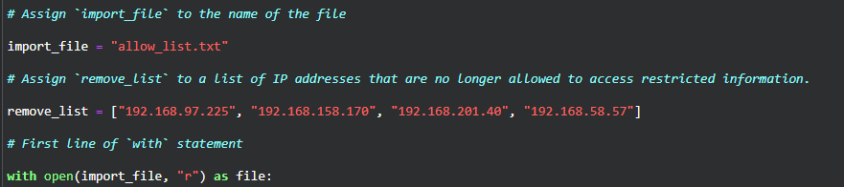

Running file will give an error due to only containing the first line of with statement.

## Read the file contents



Running file will give an error due to only containing the first line of with statement.

## Convert the string into a list

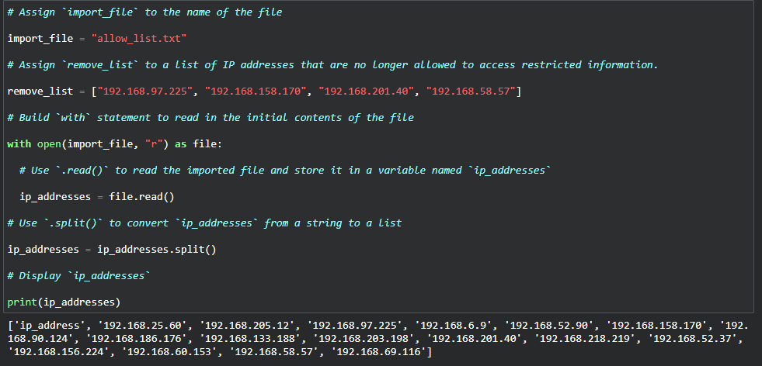

## Iterate through the remove list

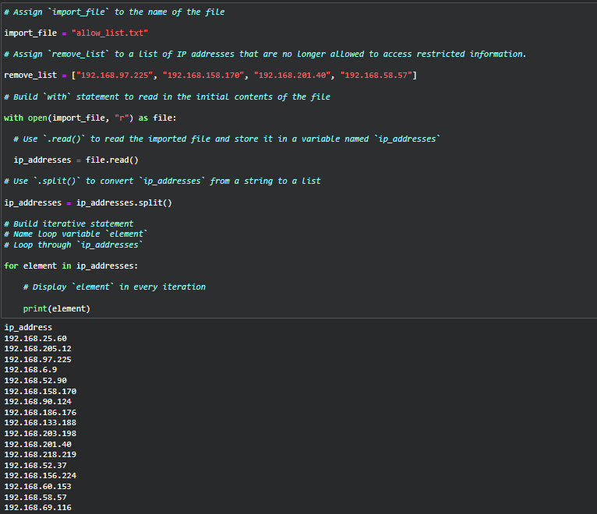

## Remove IP addresses that are on the remove list

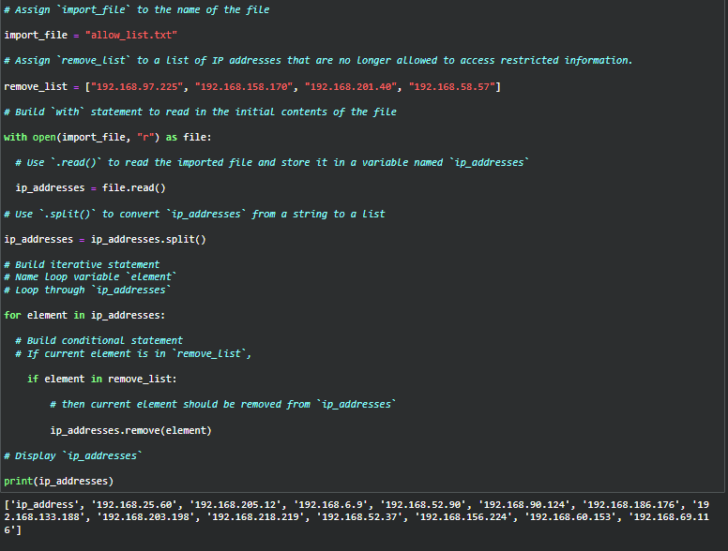

## Update the file with the revised list of IP addresses

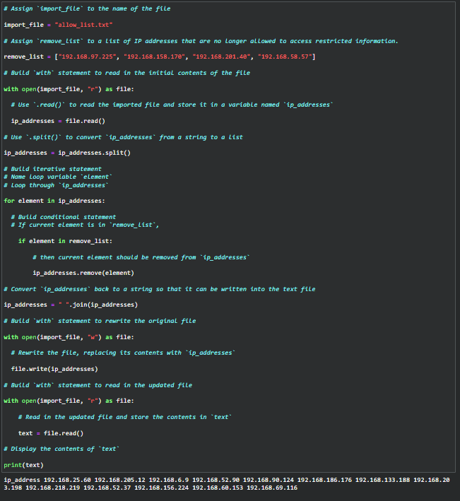

## Summary

Using “for” loops, importing files with “with open” for example, in python, make us able to retrieve and parse vital information on logs to help us identify flaws or vulnerabilities within the network.